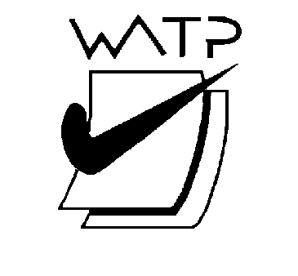

West Australian Test Papers

PHYSICS

Year 11

2003

SOLUTION BOOKLET

&

MARKING GUIDE

Markers should note that the solutions presented here are skeletal answers and
should be used as a guide only.

Alternate answers used by students may be perfectly acceptable and discretion
should be used.

Section A

- The total momentum before the crash is equal to the total momentum after the crash. The momentum after the crash is the total vector sum of all components and this will equal the initial momentum vector in both magnitude and direction. If the momenta of the individual components is summed then the total momentum would be equal to the momentum of the car as a whole before the crash. Small pieces of the car would have small masses and therefore would leave the crashed car with high velocities.

- In the case of a vehicle crashing into one of the freeway barriers, the plastic ends are designed to crumple and so increase the time that the car and barrier are in contact. Because impulse is equal to the product of the force and time, if the time is increased then the force on the car and its occupants is reduced.

3 The shiny silver blankets help to reduce heat loss from the survivor by radiation as silver
colour is a poor radiator of heat. The underside of the blanket also keeps heat generated by
the survivor within the covering by reflecting heat back to the person.

- The green/yellow wire is the earth wire. One end is connected to the metal frame of an
appliance and the other end connected to the ‘ground’ outside the building usually by a copper water pipe. It is a safety device so that when there is a short circuit in the appliance the current goes to ground rather than to a person who accidentally touches the metal frame.

- In this case the kinetic energy provided by the hammer is being transformed into heat
energy in the iron. The average kinetic energy of the particles in the iron is being increased by the transformation of energy from the movement of the hammer.

- Uranium has 92 protons, 143 neutrons and 92 electrons.

92 x 0.000 549 = 0.050 508
92 x 1.007 276 = 92.669 39
143 x 1.008 665 = 144.239 09
Total = 236.958 995

Binding energy = (236.958 995 - 235.043 92) x 931 = (1.915 075 x 931)
= 1 782.93 eV

7 Metals conduct heat better than plastic so heat is lost from the hand to the metal at a faster rate than the plastic.

8a X = 3

8b The neutrons travel at very high velocities and need to be slowed down by a moderator so
there is more chance of them causing subsequent fissions.

9a You would use a larger mirror so you can see your whole face.

9b Moving the mirror does not change the size of the image

10
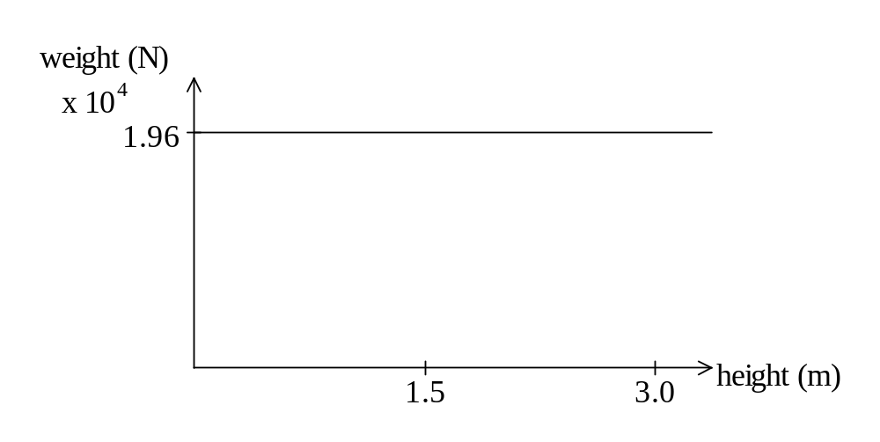
11 The dust on the windscreen scatters the light and prevents the sunlight from illuminating the
windscreen uniformly. When the dust is cleaned from the windscreen the sunlight is not
scattered and uniform illumination allows objects outside the car to be seen without
distortion.

12a v = ?
u = 5 m s⁻¹
a = 9.8 m s⁻²
s = 0.8

v² = u² + 2 a s

v² = 25 + (2 x 9.8 x 0.8 )
v = 6.38 m s⁻¹

12b v = 0
u = 6.38
a = -9.8 m s⁻²
v² = u² + 2 a s

0 = 40.68 + (2 x -9.8 x s )
s = 2.07 m

13 n = sin 45º / sin 20º

n = 0.707 / 0.342 = 2.07

The refractive index for diamond is 2.14 so the jewel is likely to be diamond.

- As the drill bit works against friction it becomes hot. Water is used to cool the drill bit
because it has a large heat capacity and can absorb more heat than oil while remaining relatively cool.

15a Ohmic resistance R = V / I = 3.2 / 5 = 0.64 Ω

15b The resistance increases as it becomes non ohmic.

15c From the graph, if the non ohmic section of the graph is considered

Non ohmic resistance R = V / I = (8 - 3.2) / 8.5 – 5) = 4.8 / 3.5 = 1.4 Ω
The resistance of 1.4 Ω is greater than the ohmic resistance of 0.64 Ω.

Section B

1a Quantity of energy = 6 x 3 x 300 joules of energy each second

In 8 hours the quantity of energy is (6 x 3 x 300) x (8 x 60 x 60) = 1.55 x 10⁸ J

1b Quantity of heat incident on the pool = 1.55 x 10 ⁸ J
1.55 x 10⁸ = 18 x 10³ x 4 180 x ΔT
ΔT = 2.06 ºC

1c 1.55 x 10⁸ = 1.8 x 10³ x 4 180 ΔT
ΔT = 20.6 ^{ο}C

1d 20 / 100 x 1.55 x 10⁸ = m (2.28 x 10⁶)
m = 13.6 kg

2a 235.043 92 140.883 54
1.008 66 91.926 27
(236.052 58 u) (232.809 81 + 3.025 995) = 235.835 81 u

mass defect = 0.216 78 u = 0.216 78 x 931 = 202 MeV

2b Energy in 1 second = [(5.5 x 10⁻⁶) / (60 x 60)] x (3 x 10⁸)²

= 1.38 x 10 ⁸ W

2c (i) Background count is the count the detector would register when there was no waste fuel present for it to detect.

2c(ii) 200 Bq to 100 Bq to 50Bq to 25 Bq to 12.5 Bq to 6.25 Bq.
6.25 Bq is below the background count of 7.0 Bq. This represents 5 half lives which is 30 x 10⁸ years.

2d(i) Absorbed dose = 20 / 70 = 0.29 Gy

2d(ii) Dose equivalent = 0.2857 x 1 = 0.29 Sv

3a Different colours have slightly different frequencies and this means they have slightly different refractive indices. This produces a different amount of refraction which leads to the dispersion of the light into its constituent colours.

3b n₁ sin θ ₁ = n₂ sin θ ₂
n₁ x sin 44 = 1 x sin 90
n₁ = 1.44

3c 88º

3d The angle of incidence is equal to the angle of reflection.

3e Ray BD is totally internally reflected and is not passing from one medium to another so it is not dispersed.

3f n₁ sin θ ₁ = n₂ sin 80
n₁ x sin 44 = 1 x sin 80
n₁ = 0.985 / 0.695 = 1.42

3g White light is a mixture of frequencies so the values are too imprecise. Yellow light has a frequency which is close to the middle frequency of the visible spectrum so it is taken as the standard.

4a(i) F = m a so a = F / m = 70 / 90 = 0.78 m s⁻²

4(ii) v² = u² + 2 a s
v² = 0 + (2 x 0.7777 x 12)
v = 4.3 m s⁻¹

4(iii) v = u + a t
  - = 0 + 0.777 t
t = 5.56 s

4b(i) v² = u² + 2 a s
v² = 4.0 + (2 x 1.54 x 50.0)
v² = 158
v = 12.6 m s⁻¹

4b(ii) Friction opposes the forward motion of the billycart so the forces on the cart are balanced.

4b(iii) v = u + a t
12.6 = 4.0 + (1.54 x t)
t = 5.58 s

4c(i) time for remaining 200 m is 200 / 12.6 = 15.9 s
Time for complete race = 15.9 + 5.56 + 5.58 = 27.0 s

4d(i) F = m x a
F = 90 x ( 12.6 - 0) / 7 = 162 N

4d(ii) momentum at start of deceleration = 90 x 12.6 = 1 134 N m
momentum after deceleration = 0 N m
change in momentum = 1 134 - 0 = 1 134 kg m s⁻¹

5a
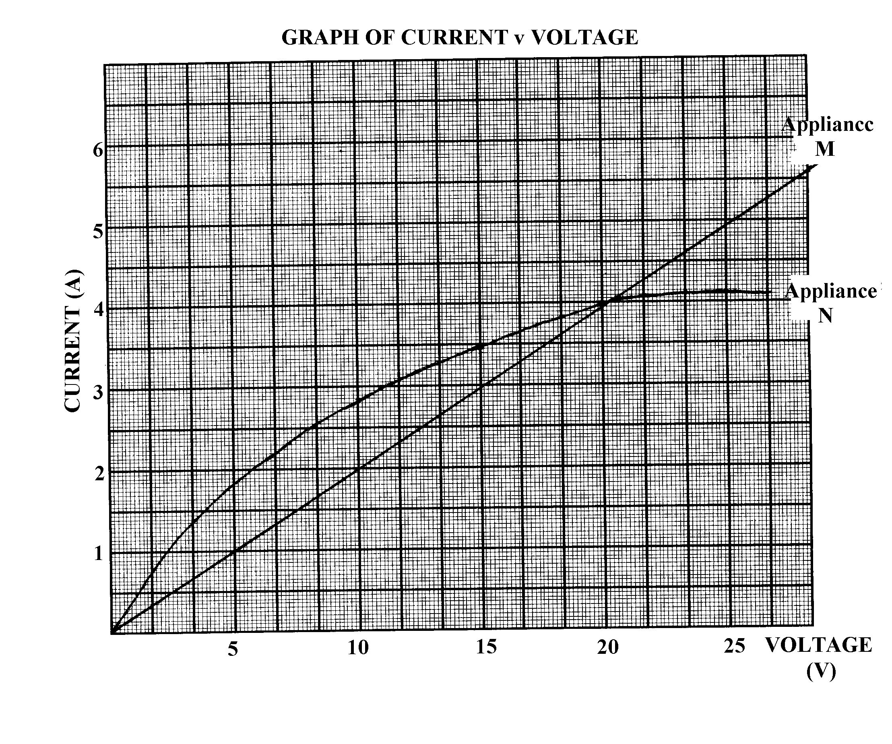
5b Appliance M obeys Ohm’s law because the ratio of current to voltage drop is linear over the measurements taken.

5c From the graph when the current through M is 2.0 A, then the voltage drop is 10 V.

5d Current through appliance N is 3 A

5e Appliances M and N are in parallel so the voltage drop across each of the appliances is the same (10 V). The total current through the circuit is shared between the two appliances in a ratio according to their resistances.

5f From the table of results, the total current in the circuit when the voltage drop is 25 V is
9 A. (5A through appliance M and 4 A through appliance N)

6a Change in momentum = 4.2 x (25 - 0) = 105 kg m s⁻¹

6b KE = 0.5 x m x v²
= 0.5 x 4.2 x 25² = 1 313 J

6c Because of the small mass of the aeroplane and its comparatively low velocity, compared to the mass of the earth, the velocity with which the earth moves is negligible.

6d I = F t
- = F x 0.75
F = 105 / 0.75 = 140 N

6e Assume acceleration due to gravity is 10 m s⁻²
Assume plane falls vertically with a starting velocity of 0 m s⁻¹

v² = u² + 2 a s
25²= 0² + (2 x 10 x s)
s = 31 m

7a Resistance in the parallel part of the circuit = R = 1/12 + 1/6 = 4 Ω

Add this to the series resistance of 4 Ω so total resistance = 4 + 4 = 8 Ω

7b V = I x R
12 = I x 8
I = 1.5 A

7c(i) The reading is zero.

7c(ii) V = 1.5 x 4 = 6 V

7d Current in the 12 Ω resistor is = 6 / 12 = 0.5 A

7e The resistance of the voltmeter is large compared to the rest of the circuit so little current will flow through it. So by having the switch open or closed it will have negligible influence on the current flowing through the circuit.

Section C

Question 1

- E = m c²
= 1 x (3 x 10⁸)² / (40 000) = 2.25 x 10¹² J

2 E = 100 x 10⁶ x (2 x 24 x 60 x 60) = 1.73 x 10¹³ J

3 The rest mass of a particle is the mass of its nucleus when it is stationary. That is, the kinetic energy of the particle is negligible.

4 The rest masses of the products of the reaction must be less than rest mass of the original ingredients because it is that mass defect which accounts for the energy which is released.

5 The origin of the binding energy is the difference in mass of the products and the reactants
and is always positive in both fission and fusion.

6 Iron is the element

7 This position is when elements of lower atomic number are more likely to undergo fusion
and the higher atomic numbered elements are more likely to undergo fission.

- The two ways are:

By the reactants splitting into smaller fragments which is fission or by elements joining together to form larger elements which is fusion.

Question 2

1 The active system has a heat transfer control system which operates at high temperatures.
The passive system relies upon natural flow of water due to convection.

2(i) Concave mirrors focus solar radiation by reflection.

2(ii) Convex lenses focus solar radiation by refraction.

- Due to convection currents set up in the storage tank, the warmer water would be present at
the top of the tank.

- The larger the surface area of a solar pond the greater the quantity of solar radiation that
can be collected. The quantity of solar radiation is quoted in W m⁻².

- The black colouring aids the absorption of the solar radiation.

- The penetration of solar radiation would be reduced by the increased depth.

- The higher density layer of the pond at the bottom contains heat energy which reduces the
loss of heat energy through evaporation if the heat energy was concentrated in the top layers.

- The ponds would need to be located where there is a consistent supply of solar radiation.
This would limit their location to places with reliable temperate climates.

9 When water enters a partial vacuum the water evaporates rapidly. This process requires
latent heat which is absorbed from the surroundings thus having a cooling effect.

